**RTS/RTR and XFC Protocols**

* Definitions
  + RTS = Ready to Send
  + RTR = Ready to Receive
  + XFC = Transfer Complete = RTS & RTR
* Timing Diagrams
* Case 1 (RTS is on before RTR)
  + Data must be valid when RTS is asserted
  + Data transitions to ‘don’t care’ on the falling edge of RTS
  + RTS can be on as long as there is data to send
  + XFC = RTS & RTR

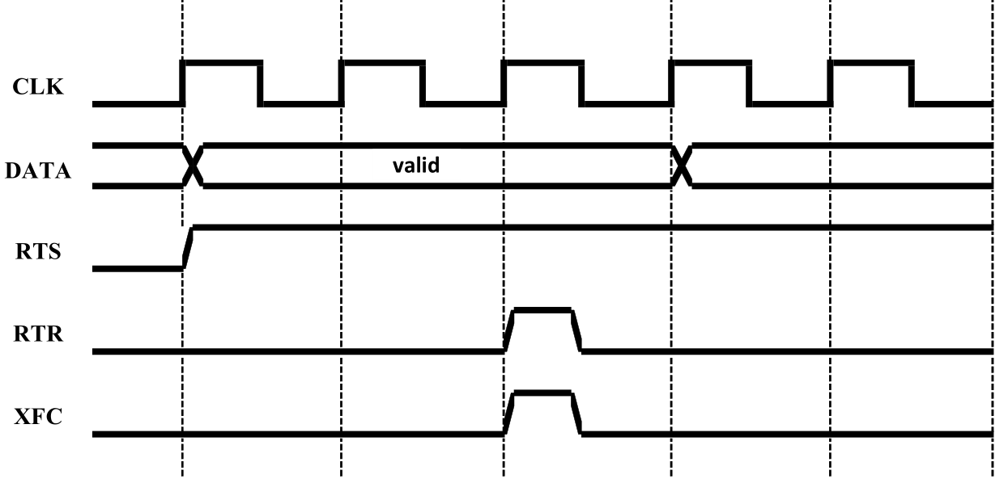

* Case 2 (RTR is on before RTS)
  + Data must be valid when RTS is asserted
  + Data transitions to ‘don’t care’ on the falling edge of RTS
  + RTR can be on as long as data can be received
  + XFC = RTS & RTR

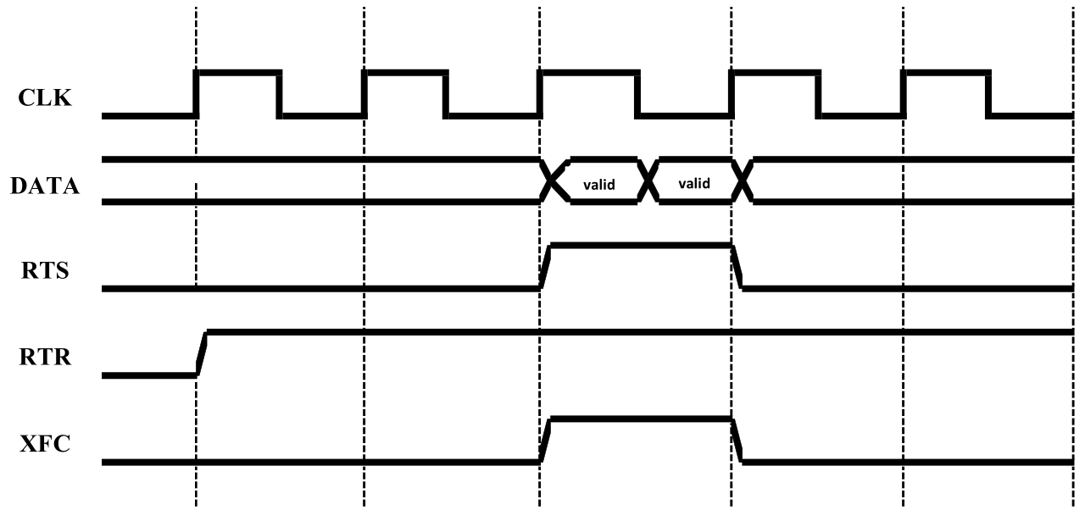

* Case 3 (RTR and RTS turn on at the same time)
  + Data must be valid when RTS is asserted
  + Data transitions to ‘don’t care’ on the falling edge of RTS
  + XFC = RTS & RTR

